|  |  |  |
| --- | --- | --- |
| **المملكة العربية السعودية**  **وزارة التعليم**  **إدارة تعليم منطقة الرياض** | kingdom-of-saudi-arabia-vision-2030-logo-vector | **اسم الطالبة:**  **............................................** |
| **مدرسة: ابتدائية أبناء الامه الأهلية للبنات** | **رقم الجلوس: ( )** |
| **اليوم: .............................**  **التاريخ: .............................** | **عدد الأسئلة: (6) أسالة** |
| **الزمن: ساعة ونصف** | **درجة الاختبار من: (30)** |
| **عدد الصفحات: (4) صفحات** | **الصف: السادس الابتدائي** |
| **اسم المصححة:** | **التوقيع:** | **الدرجة رقما:** |
| **اسم المراجعة:** | **التوقيع**: | **الدرجة كتابة:** |
| **الاختبار النهائي لمادة اللغة الإنجليزية الفصل الدراسي الثالث / الدور الأول للعام الدراسي 1443 هـ** | | |

**Total _____**

**30**

**________________________________________________________________________________________**

**6**

Q1. General Questions:

Choose:

**1** - How many students are there in your school? **---------.**  .................................................................................................................................................................................................. **_________**

2-What would you like to drink? **---------.**

**3**- What time does your school start? **---------.**  ................................................................................................................................................................................................... _______ ___________

**---------.**   **4** –Where is the post office? ................................................................................................................................................................................................... ___________

5 – Where are you going? ---------.

__________

6- Did you brush your teeth this morning? ----------------------------------------------.

.

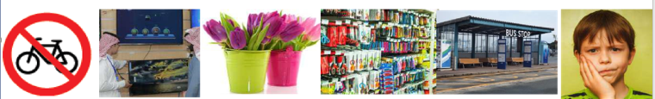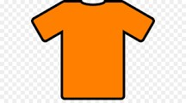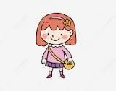

1- Flowers 2- bus stop 3- no bicycles 4-toothache 5- bookstore 6- business

Q2. Vocabulary:

Choose:

**6**

**( ) ( ) ( ) ( ) ( ) ( )**

**____________________________________________________________**

Q3. Grammar:

Choose:

**5**

1-This year I **(like – liked**) Math.

2- I should (**eats – eat**) three meals a day.

3- There (**were – was**) two floors.

4- I (**is going – am going**) to the stationery store.

5-Last year we (**go – went**) to Riyadh.

6-This year I (**am – was**) in the 6th grade

1. 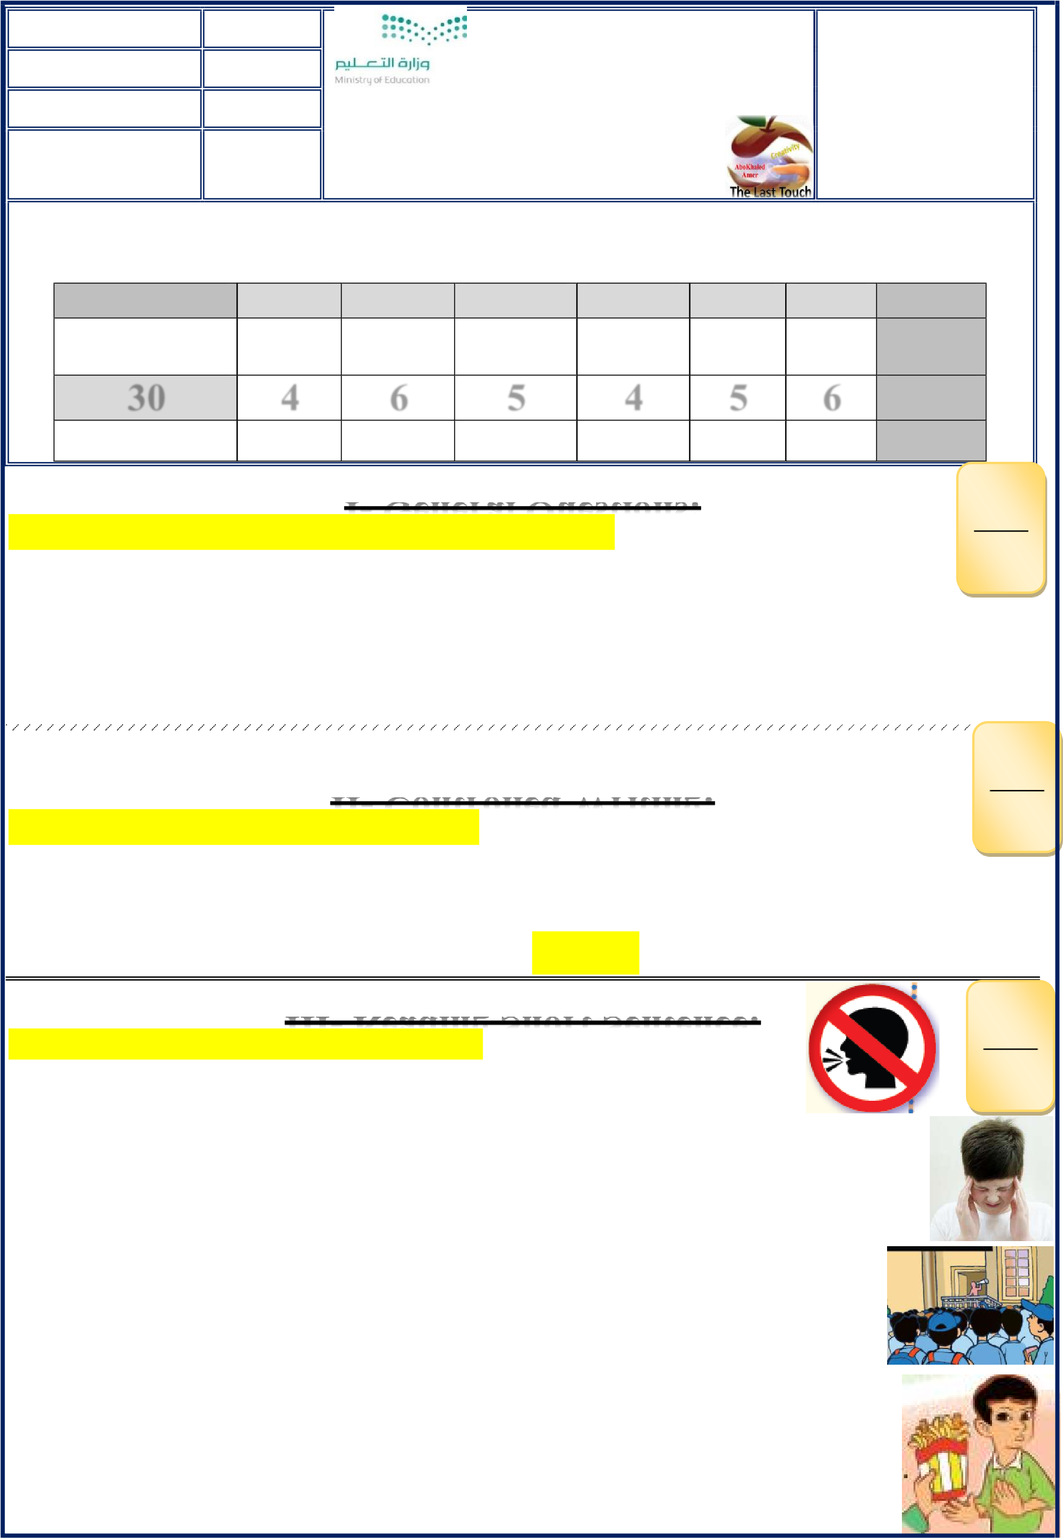**There are about 200 students. ( )**

**4**

Q4. Match:

1. **Don't shout speak clearly.**   **( )**
2. **You shouldn't eat junk food.**  **( )**



**4. I have a bad headache. ( )**

__________________________________________________________

Q5. Orthography:

Fill in the missing letters:

**4**

**(ir _sq _ ir _ sk _ ur _ sc _ u-e_ ue _ng)**



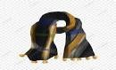  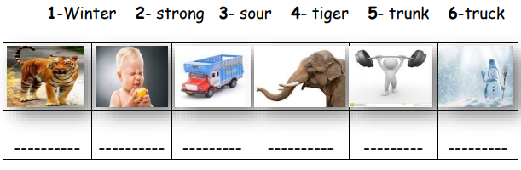  

1-G _ _l 2-B _ _d 3-B_ _ger 4- _ _uare 5- _ _irt 6-_ _arf 7-h _g _ 8-mosq_ _

اسم ال**مؤوء**

**____________________________________________________________**

**Q6. Do as shown between brackets: ___**

**5**

1- you? - I – Can –help (Rearrange)> ____ ____ _____ ___ ___?

2- (complete) Sunday, ………………., Tuesday.

**5**

3- e _ t _ s _ u _ s_i (rearrange) >. ----------------------------------.



4-bakery. _ to _ the_going_She's (rearrange) > ----------------------------------.  
_

5- (complete) I shouldn't -------------to many computer games.?

**\* انتهت الأسئلة**

**Good luck my sweet**

**T. Ebtsam Aldosari**